

SAFC POOLS
MARKETING TOOLKIT
February 2020

We are pleased to provide February’s Toolkit of SAFC Pools Marketing Assets.
Once again, we have some amazing prizes to give away in addition to ‘winning the pools’, including a Trip to Paris with tickets to the Grand Slam Women’s tennis final
a guaranteed £100,000 lump sum cash prize
and a New Car.
Performance Reporting on January’s Activity is included for your information.

Your Toolkit Portal Login Details
To access the SAFC Toolkit Portal please click here: https://footballpools.levelonline.co.uk/
Your unique login details are as follows:
Username: Sunderland
Password: m9CaqJwrEL[t@g+>

Instructions:
- Under My Workspaces on the left-hand-side, Click Sunderland Pools
- Click January 2020 Toolkit
- Click a respective Folder and select an Asset
- Download the Asset using the right-hand-side menu

We look forward to seeing February’s assets live.

CONTENTS
January Proposed Schedule of Activity…………………………………………………… Page 2
Emails …………………………………………….……………………………………………………… Page 3-4
Website Banners……………………………………………………………………………………. Page 5
Match-Day Advertising…………………………………………………………………………… Page 6
Social Media Posts – Weeks 5 / 6 / 7 / 8…………………………………………………. Pages 7-10
December 2019 Performance ………………………………………………………………………. Page 11

FEBRUARY 2020 - PROPOSED SCHEDULE OF ACTIVITY
 | February 2020
 | w/c 03/02 |  |  | w/c 10/02 |  |  | w/c 17/02 |  |  |  | w/c 24/02
 | Week 5 |  |  | Week 6 |  |  | Week 7 |  |  |  | Week 8
 | Start | Mid | End | Start | Mid | End | Start | Mid | End | Start |  | Mid | End
Email | Email 1 |  |  |  |  |  | Email  2
Web Banner | Banner of choice
Match-Day Advertising* |  |  | V  Ips-wich |  |  |  |  |  | V  Bristol
Social Media | Post 1 | Post 2 | Post 3 | Post 4 | Post 5 | Post 6 | Post 7 | Post 8 | Post 9 | Post 10 |  | Post 11 | Post 12
*If free Advertising space is available in the Programme Ad or on In-Stadium Screens.

Important Deadlines
Super Prize Draw
- February 29th is the last Pools Competition that SAFC Pools Players can enter to qualify for the February Super Prize Draw. Therefore Marketing of the Experience Trip to Paris, the guaranteed £100,000 cash prize and the new Car, must take place before February 29th.
SAFC Pools LeaderBoard
- In January the SAFC Pools Leaderboard will be open on the below competitions:
Saturday 15th February / Saturday 29th February
Hospitality Tickets
- Hospitality Tickets for the Gillingham game need to be promoted before the pools competition on Saturday 22nd Feb.
Free Play Promo
- All marketing for the Free Play Promo must take place between February 17th and February 26th. No promotion of this promo can occur before or after these dates.
EMAIL 1 (Send w/c 03/02)

Email Banner (please download the following file from your Portal)
Please tag the Email with the following Short Link, so that we can track conversion performance via Google Analytics:



Email Subject
Win with SAFC Pools – Support SAFC

Email Title
Play SAFC Pools – Support SAFC

Body Copy
How to Play
Pick 10 matches from a list of 49. Score 3 points for a score draw, 2 points for a 0-0 and 1 point for a Home/Away win. Cash prizes are up for grabs for the highest weekly scores!

Super Prize Draw
Every month, there is a Super Prize Draw that all customers have the chance to be a part of! This month’s prizes include a Trip to Paris, a guaranteed £100k in cash and a new Audi A1! All this (and more) can be won by playing SAFC Pools!

Supporting SAFC
Every £1 you spend, SAFC benefits! This could mean thousands of pounds going back to the Club towards stadium improvements and youth development and YOU would be the person contributing.

Signing up is easy! First four games free for new players then only £1 per play!

Because…There’s more than one way to be a supporter

T&C’s apply

EMAIL 2 (Send w/c 17/02)

Email Banner (please download the following file from your Portal)

Please tag the Email with the following Short Link, so that we can track conversion performance via Google Analytics:

Email Subject
Free Play worth up to £10 every month with SAFC Pools

Email Title
Support SAFC – Play SAFC Pools

Body Copy
Fancy helping raise money for your Club? Fancy getting Free Pools worth up to £10 every month? Don’t miss out! It’s simple, and we give you your first four games free.

- Subscribe to SAFC Pools by February 26th
- Receive your Free Lucky Dip by February 28th
- Enjoy increased chances of winning every time you play!

With this amazing offer you’re increasing your chances of winning -
From a share of the prize pool, including a £3M Jackpot with every game, to our amazing monthly Super Prize Draws, featuring sensational experience trips of a life-time, guaranteed cash prizes, new cars, and much more.

Because…There’s more than one way to be a supporter! Sign up today & play.
T&C’s apply

WEBSITE BANNERS

Banners for your Website… (Please download the following files from your Portal)

This month we have provided you with a choice of Banners for your website.



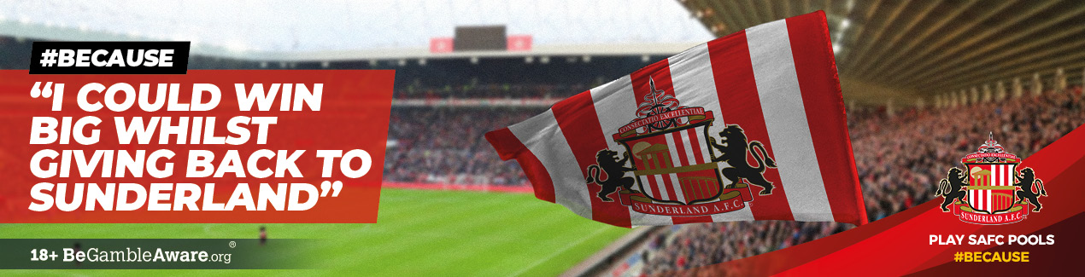

MATCHDAY ADVERTISING

Match Programme Ad (Please download the following PDF file from your Portal)



Jumbo Screen Ad (Please download the following video file from your Portal)
To be shown at SAFC v Bristol game only as this game is within the Promo qualifying period

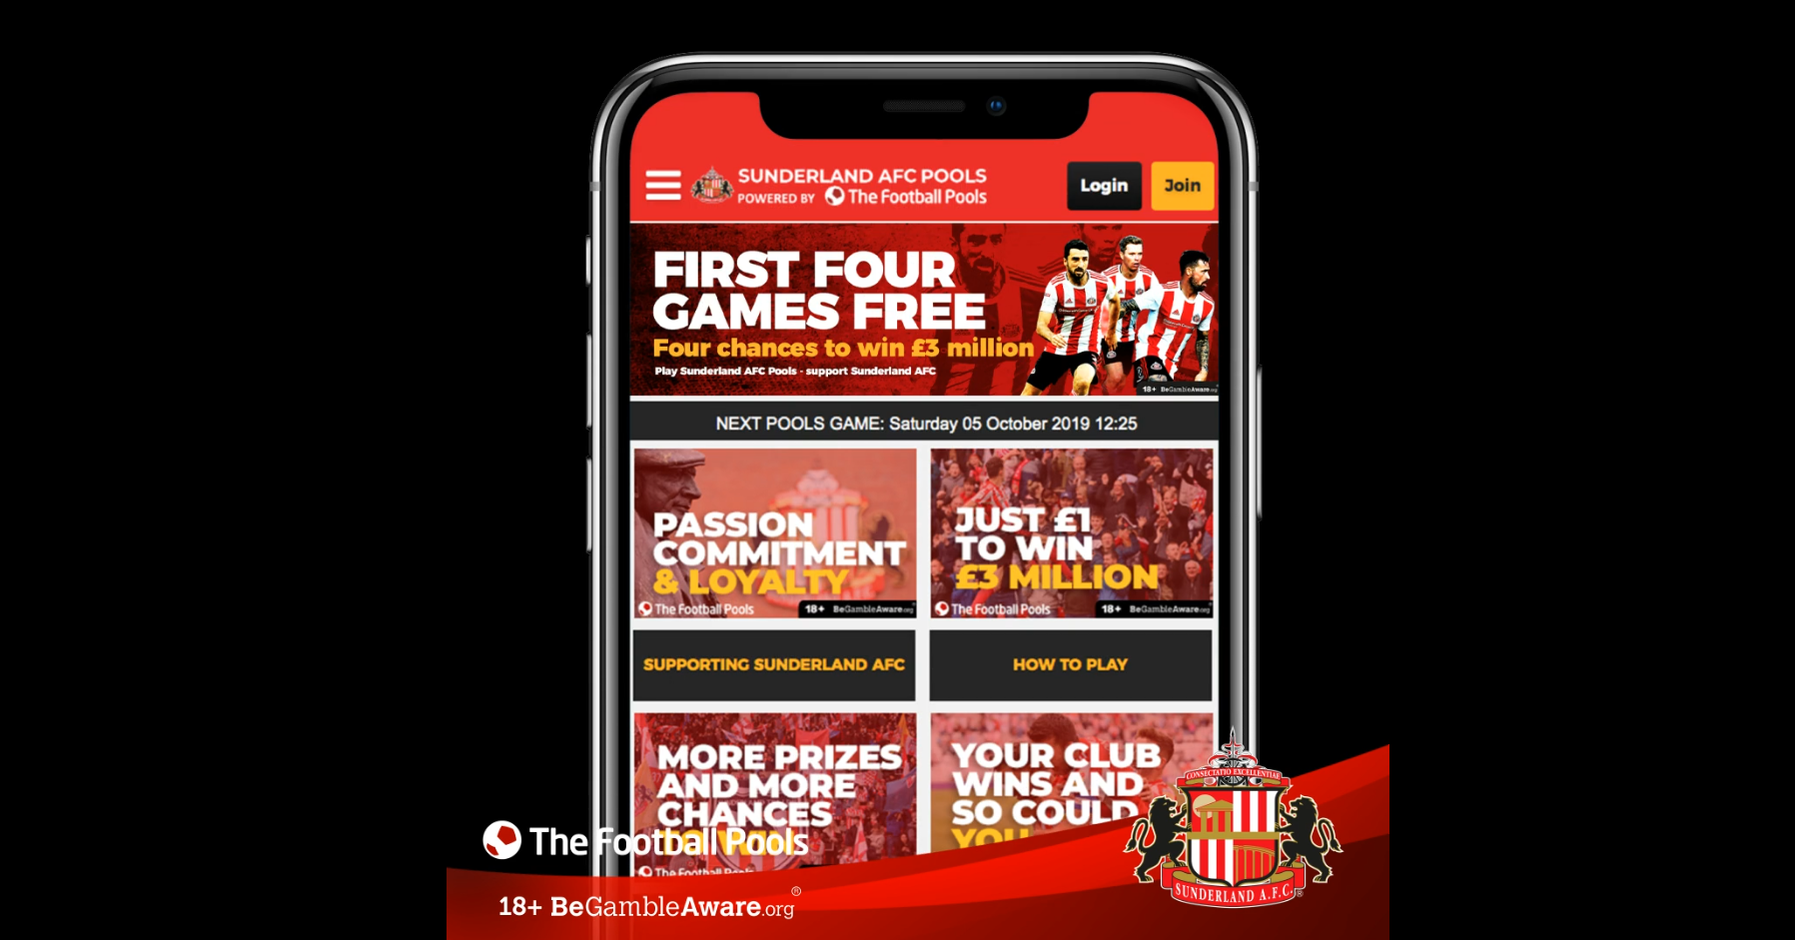

SOCIAL MEDIA POSTS (Feel free to use Emojis)

Banners for Facebook/Instagram and Twitter (Please use attached PNG files)

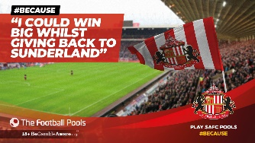
Week 1 (w/c 03.02) - Post 1 - Beginning Week
Banner: I Could Win Whilst Giving Back to SAFC
Social Text and Tagged URLs:
Facebook/Instagram
Pools | Pick 10 matches from 49.
Score 3pts for a score draw, 2pts for a 0-0 and 1pt for a Home/Away win. Cash prizes for highest weekly scores.
£3m for correctly predicting 9 score draws when exactly 9 matches on the coupon end in a score draw
http://bit.ly/36FFwD9 T&Cs apply
Twitter
Pools | Pick 10 matches from 49.
Score 3pts for a score draw, 2pts for a 0-0 and 1pt for a Home/Away win. Cash prizes for highest weekly scores.
£3m for correctly predicting 9 score draws when exactly 9 matches on the coupon end in a score draw
http://bit.ly/316civS T&Cs apply

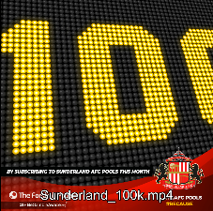
Week 1 (w/c 03.02) - Post 2 - Mid Week
Video Post - £100k
Social Text and Tagged URLs:
Facebook/Instagram
Play SAFC Pools this February #because we’re giving one lucky player a guaranteed £100k! Score 20 points or more in any Pools competition this February and you’ll be in the draw! Play here: http://bit.ly/2u75JgA T&Cs apply
Twitter
Play SAFC Pools this February #because we’re giving one lucky player a guaranteed £100k! Score 20 points or more in any Pools competition this February and you’ll be in the draw! Play here: http://bit.ly/2u7x56i T&Cs apply


Week 1 (w/c 03.02) - Post 3 - End of Week
Banner: I Could Win A Trip To Paris
Social Text and Tagged URLs:
Facebook/Instagram
This month’s SAFC Pools Super Prize Draw includes a trip to Paris with tickets to the Women’s French Open! Subscribe, support the club and have the chance of winning this amazing prize as a bonus! Play here: http://bit.ly/2OhkCUu T&Cs apply
Twitter
This month’s SAFC Pools Super Prize Draw includes a trip to Paris with tickets to the Women’s French Open! Subscribe, support the club and have the chance of winning this amazing prize as a bonus! Play here: http://bit.ly/2S1CTpS T&Cs apply
Week 2 (w/c 10.02) - Post 4 - Beginning Week
Banner:
Social Text and Tagged URLs:
Facebook/Instagram
SAFC Pools are giving away 4 x 2 tickets to the SAFC Hall of Fame Dinner on March 6th! To be in with a chance of winning a pair, subscribe to SAFC Pools today! Everyone who plays in the Feb 22nd Pools competition, will enter the draw! Play here:
Twitter
SAFC Pools are giving away 4 x 2 tickets to the SAFC Hall of Fame Dinner on March 6th! To be in with a chance of winning a pair, subscribe to SAFC Pools today! Everyone who plays in the Feb 22nd Pools competition, will enter the draw! Play here:

Week 2 (w/c 10.02) - Post 5 - Mid Week
Banner: I Could Win Whilst Giving Back to SAFC
Social Text and Tagged URLs:
Facebook/Instagram
Play SAFC Pools #because every time you play, SAFC FC benefits! Your support could mean thousands of pounds going towards the club. Find out more:
Twitter
Play SAFC Pools #because every time you play, SAFC FC benefits! Your support could mean thousands of pounds going towards the club. Find out more:

Week 2 (w/c 10/02) Post 6 – End of Week
Banner:
Social Text and Tagged URLs:
Facebook/Instagram
SAFC Pools are giving away 4 x 2 tickets to the SAFC Hall of Fame Dinner on March 6th! To be in with a chance of winning a pair, subscribe to SAFC Pools today! Everyone who plays in the Feb 22nd Pools competition, will enter the draw! Play here:
Twitter
SAFC Pools are giving away 4 x 2 tickets to the SAFC Hall of Fame Dinner on March 6th! To be in with a chance of winning a pair, subscribe to SAFC Pools today! Everyone who plays in the Feb 22nd Pools competition, will enter the draw! Play here:

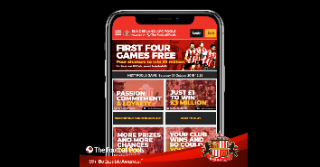
Week 3 (w/c 17.02) - Post 7 – Beginning Week
Banner: Free Play worth up to £10 every month
Social Text and Tagged URLs:
Facebook/Instagram
SAFC Pools New Customer Offer!
Subscribe to SAFC Pools by February 26th and get one free line, every time you play – Forever. That’s like getting 1 FREE line on the lottery, every week!
Find out more:
T&Cs apply
Twitter
SAFC Pools New Customer Offer!
Subscribe to SAFC Pools by February 26th and get one free line, every time you play – Forever. That’s like getting 1 FREE line on the lottery, every week!
Find out more:
T&Cs apply


Week 3 (w/c 17.02) - Post 8 – Mid Week
Banner: I Could Go To The Match In Style
Social Text and Tagged URLs:
Facebook/Instagram
Subscribe to SAFC Pools? #Because if you are, you could win Hospitality Tickets in the Montgomery Suite for the Gillingham game! Mix with club legends, meet the MOTM and enjoy a 3-course meal with this SAFC Pools prize. Play here: T&Cs apply
Twitter
Subscribed to SAFC Pools? #Because if you are, you could win Hospitality Tickets in the Montgomery Suite for the Gillingham game! Mix with club legends, meet the MOTM and enjoy a 3-course meal with this SAFC Pools prize. Play here: T&Cs apply

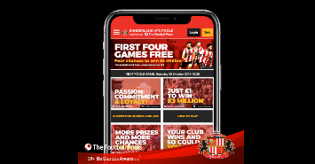
Week 3 (w/c 17.02) - Post 9 – End of Week
Banner: Free Play worth up to £10 every month
Social Text and Tagged URLs:
Facebook/Instagram
Subscribe to SAFC Pools by February 26th and you’ll get up to £10 Free Play every month – Forever! Don’t miss out on this exclusive promotion! Find out more: T&Cs apply
Twitter
Subscribe to SAFC Pools by February 26th and you’ll get up to £10 Free Play every month – Forever! Don’t miss out on this exclusive promotion! Find out more: T&Cs apply

Week 4 (w/c 24.02) - Post 10 - Beginning Week
Banner: Free Play worth up to £10 every month
Social Text and Tagged URLs:
Facebook/Instagram
LAST CHANCE | Subscribe to SAFC Pools by 11:59pm on February 26th to get 1 Free Lucky Dip, every time you play – Forever. That’s an additional chance to win with every game you play! Subscribe now before time runs out! T&Cs apply
Twitter
LAST CHANCE | Subscribe to SAFC Pools by 11:59pm on February 26th to get 1 Free Lucky Dip, every time you play – Forever. That’s an additional chance to win with every game you play! Subscribe now before time runs out! T&Cs apply

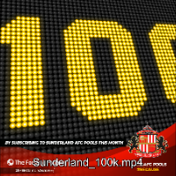
Week 4 (w/c 24/02) - Post 11 - Mid Week
Banner:
Social Text and Tagged URLs:
Facebook/Instagram
Play SAFC Pools this weekend #because there’s still time to be in with a chance to win a guaranteed £100k! If you score 20 points or more in any Pools competition this February and you’ll be in the draw! Play here: T&Cs apply
Twitter
Play SAFC Pools this weekend #because there’s still time to be in with a chance to win a guaranteed £100k! If you score 20 points or more in any Pools competition this February and you’ll be in the draw! Play here: T&Cs apply


Week 4 (w/c 24.02) - Post 12 – End of Week
Banner:
Social Text and Tagged URLs:
Facebook/Instagram
If you’ve scored 20+ points in any SAFC Pools competition this month, you’ll be in our Super Prize Draw! In which you could win a brand new Audi, £100k or a trip to Paris! Play now:
Twitter
If you’ve scored 20+ points in any SAFC Pools competition this month, you’ll be in our Super Prize Draw! In which you could win a brand new Audi, £100k or a trip to Paris! Play now:

JANUARY 2020 - PERFORMANCE

Thank you for your support in executing January’s Toolkit. Below is a performance summary.

New Acquisition
- January’s marketing activity generated 9 new customers.
- The current active SAFC Pools customer base increased in December to 186.
(Please note: January typically sees a high rate of cancellations following the Xmas period, so a stable base is a positive result).

 | October  (Weeks 40-43)* | November  (Weeks 44-47)* | December  (Weeks 48-50)* | January  (Weeks 1-4)
New Players | 30 | 11 | 9 | 21
Total Players | 191 | 188 | 185 | 186
*Reporting dates may vary slightly to Toolkit dates

The below graphs provide an overview of January’s performance (number of website users + subscriptions), and a week-on-week performance view since August launch.
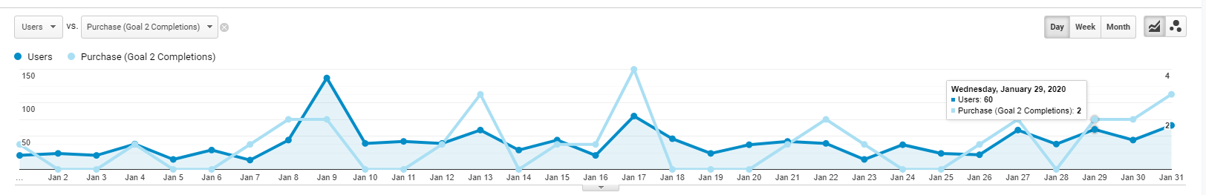
January Performance

Dec Email

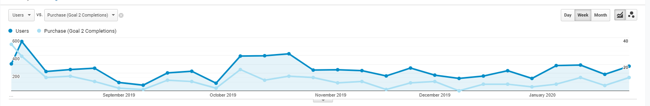

#

Commentary
- Despite marketing activity driving spikes during the month, engagement overall has remained at a consistently low level since November and subscriptions numbers are below target.
- Despite this, and the total net customer base remaining relatively flat, retention levels are very high with 90% of customers continuing to play after their four free games and after 1st payment.
- Focus therefore needs to continue on awareness build.

Recommendations
- This month we will be testing different types of content in an attempt to drive higher engagement. This includes a first Promotion, as well as an increased number of Club prizes.
- The Promotion is a very strong offer and we recommend strong execution with an Email send solely focused on this, as well as Social Media activity. It would be great to see two Email sends this month, but if not possible then priority should be the Promo Email.

THANK YOU

Your support in executing this Toolkit is appreciated.
Our Partnership is important to us and we are working to provide the right
support to make promoting SAFC Pools easy and efficient for you.
Working together we will build a strong subscription base and
valuable financial contribution back to your club.

